Ian Borwick – 250950449

[iborwick@uwo.ca](mailto:iborwick@uwo.ca)

CS 4442 – Assignment 1

Contents

Question 1 2

1a) 2

1b) 3

1c) 4

1d) 5

Question 2 6

2a) 6

2b) 7

2c) 8

2d) 9

2e) 10

2f) 11

Question 3 12

3a) 12

3b) 14

3c) 15

# Question 1

## 1a)

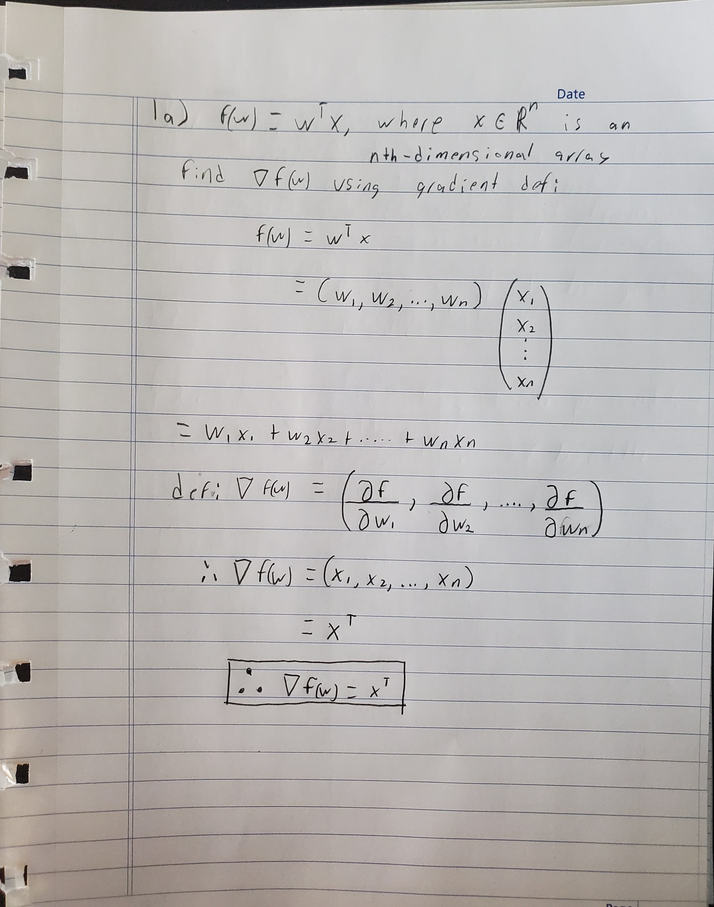

## 1b)

## 1c)

## 1d)

# Question 2

## 2a)

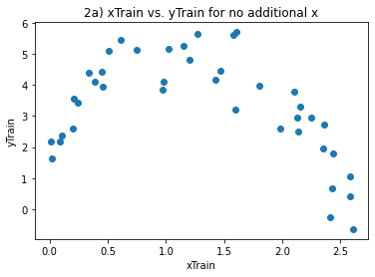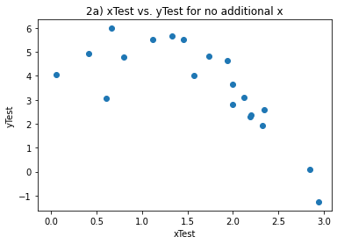

## 2b)

The training error for this regression model is: [2.17394558]

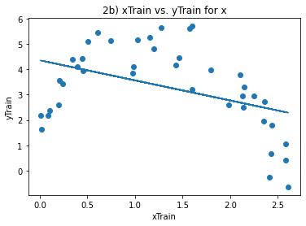

## 2c)

The test error for this regression model is: [2.31187535]

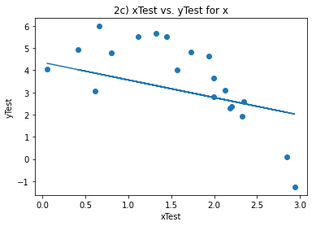

## 2d)

The training error for the x^2 regression model is: [0.4846845]

The test error for the x^2 regression model is: [0.75736357]

The x^2 regression is a better fit than linear

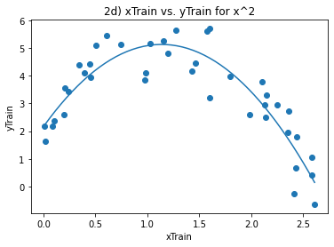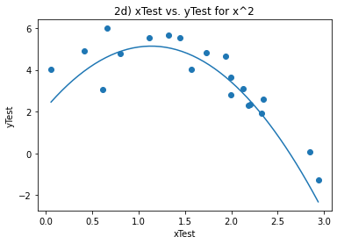

## 2e)

The training error for the x^3 regression model is: [0.48055213]

The test error for the x^3 regression model is: [0.69112454]

The x^3 regression is a better fit than linear and better than x^2

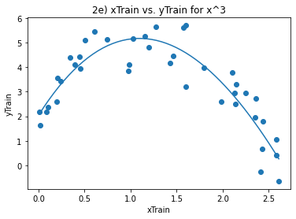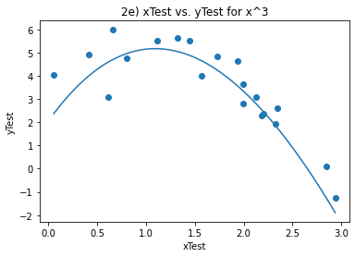

## 2f)

The training error for the x^4 regression model is: [0.43664763]

The test error for the x^4 regression model is: [1.55846948]

The x^4 regression is a better fit than linear but worse than the x^2 and x^3

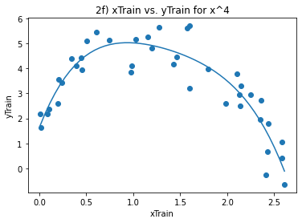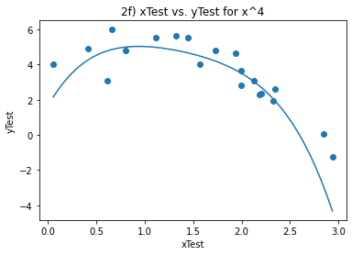

# Question 3

## 3a)

Train Error values:

Blue - 0.01 : [0.44766944]

Orange - 0.1 : [0.50764684]

Green- 1 : [0.61438502]

Red - 10 : [0.79919963]

Purple - 100 : [1.06408674]

Brown - 1000 : [1.24504551]

Pink - 10000 : [1.58866293]

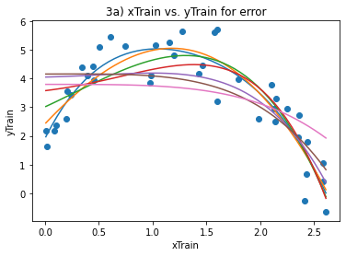

Test Error values:

Blue- 0.01 : [1.1142357]

Orange - 0.1 : [0.75921838]

Green - 1 : [1.19209465]

Red - 10 : [1.56971215]

Purple -100 : [0.97921956]

Brown - 1000 : [0.95177873]

Pink - 10000 : [1.50004816]

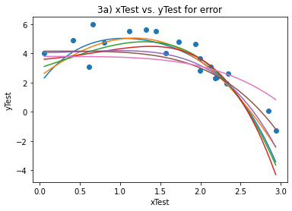

The best lambda fit is for 0.1 as it had the lowest error for the testing data

## 3b)

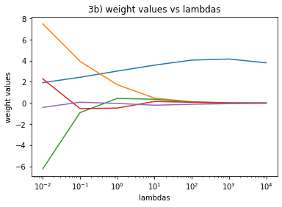

## 3c)

Average Errors

0.01 : [0.56797556]

0.1 : [0.61637959]

1 : [0.74211609]

10 : [0.92384521]

100 : [1.17268211]

1000 : [1.32873231]

10000 : [1.76322053]

The best lambda for c) was 0.01 and for a) it was 0.1 so it did changed

